ASSIGNMENT 11.2

2303A51574

BATCH-29

Task Description -1 – (Stack Using AI Guidance)
• Task: With the help of AI, design and implement a Stack data
structure supporting basic stack operations.

CODE:
#create a Queue data structure following FIFO principles
class Queue:
def __init__(self):
self.items = []

def is_empty(self):
return len(self.items) == 0

def enqueue(self, item):
self.items.append(item)

def dequeue(self):
if not self.is_empty():
return self.items.pop(0)
else:
raise IndexError("Dequeue from an empty queue")

def peek(self):
if not self.is_empty():
return self.items[0]
else:
raise IndexError("Peek from an empty queue")

def size(self):
return len(self.items)
# Example usage:
if __name__ == "__main__":
queue = Queue()
queue.enqueue(1)
queue.enqueue(2)
queue.enqueue(3)
print("Front item:", queue.peek()) # Output: Front item: 1
print("Queue size:", queue.size()) # Output: Queue size: 3
print("Dequeued item:", queue.dequeue()) # Output: Dequeued item: 1
print("Queue is empty:", queue.is_empty()) # Output: Queue is empty: False
print("Dequeued item:", queue.dequeue()) # Output: Dequeued item: 2
print("Dequeued item:", queue.dequeue()) # Output: Dequeued item: 3
print("Queue is empty:", queue.is_empty()) # Output: Queue is empty: True

OUTPUT:
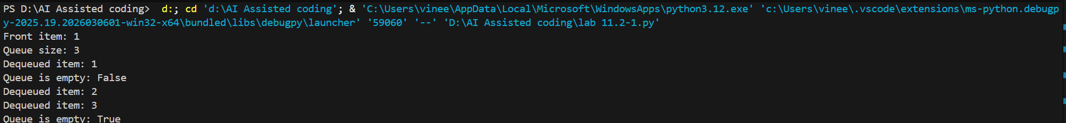

Task Description -2 – (Queue Design)
• Task:Use AI assistance to create a Queue data structure
following FIFO principles
Expected Output:
• A complete Queue implementation including enqueue, dequeue,
front element access, and size calculation

CODE:
# design and implement a Stack data structure supporting basic stack operations.
class Stack:
def __init__(self):
self.stack = []

def push(self, item):
self.stack.append(item)

def pop(self):
if not self.is_empty():
return self.stack.pop()
else:
raise IndexError("Stack is empty")

def peek(self):
if not self.is_empty():
return self.stack[-1]
else:
raise IndexError("Stack is empty")

def is_empty(self):
return len(self.stack) == 0

def size(self):
return len(self.stack)
# Example usage:
if __name__ == "__main__":
stack = Stack()
stack.push(1)
stack.push(2)
stack.push(3)
print("Top item:", stack.peek()) # Output: Top item: 3
print("Stack size:", stack.size()) # Output: Stack size: 3
print("Popped item:", stack.pop()) # Output: Popped item: 3
print("Stack is empty:", stack.is_empty()) # Output: Stack is empty: False
print("Popped item:", stack.pop()) # Output: Popped item: 2
print("Popped item:", stack.pop()) # Output: Popped item:
print("Stack is empty:", stack.is_empty()) # Output: Stack is empty: True

OUTPUT:
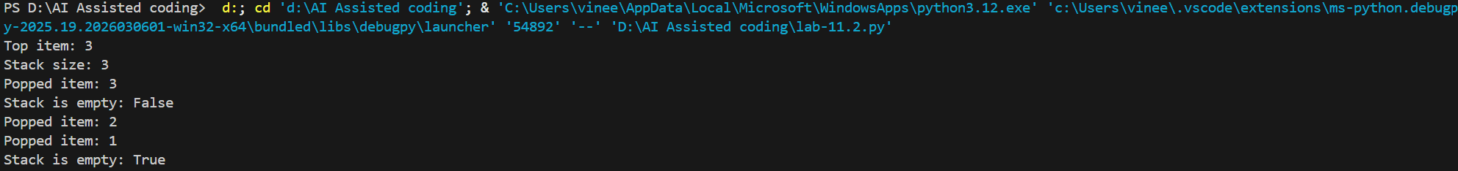

Task Description -3 –(Singly Linked List Construction)
• Task: Utilize AI to build a singly linked list supporting insertion
and traversal.
Expected Output:
• Correctly functioning linked list with node creation, insertion
logic, and display functionality.

CODE:
#build a singly linked list supporting insertion and traversal.
class Node:
def __init__(self, data):
self.data = data
self.next = None
class SinglyLinkedList:
def __init__(self):
self.head = None

def insert(self, data):
new_node = Node(data)
if not self.head:
self.head = new_node
return
last_node = self.head
while last_node.next:
last_node = last_node.next
last_node.next = new_node

def traverse(self):
current_node = self.head
while current_node:
print(current_node.data)
current_node = current_node.next
# Example usage:
if __name__ == "__main__":
linked_list = SinglyLinkedList()
linked_list.insert(1)
linked_list.insert(2)
linked_list.insert(3)
print("Linked List Traversal:")
linked_list.traverse() # Output: 1 2 3

OUTPUT:

Task Description -4 – (Binary Search Tree Operations)
• Task: Implement a Binary Search Tree with AI support focusing
on insertion and traversal.
Expected Output:
• BST program with correct node insertion and in-order traversal
output.

CODE:
#implement the binary search tree and implement the following functions like insert, delete, search, inorder traversal, preorder traversal, postorder traversal
class TreeNode:
def __init__(self, key):
self.left = None
self.right = None
self.val = key
class BinarySearchTree:
def __init__(self):
self.root = None

def insert(self, key):
if self.root is None:
self.root = TreeNode(key)
else:
self._insert_recursively(self.root, key)

def _insert_recursively(self, node, key):
if key < node.val:
if node.left is None:
node.left = TreeNode(key)
else:
self._insert_recursively(node.left, key)
else:
if node.right is None:
node.right = TreeNode(key)
else:
self._insert_recursively(node.right, key)

def search(self, key):
return self._search_recursively(self.root, key)

def _search_recursively(self, node, key):
if node is None or node.val == key:
return node
if key < node.val:
return self._search_recursively(node.left, key)
return self._search_recursively(node.right, key)

def inorder_traversal(self):
return self._inorder_recursively(self.root)

def _inorder_recursively(self, node):
res = []
if node:
res = self._inorder_recursively(node.left)
res.append(node.val)
res = res + self._inorder_recursively(node.right)
return res

def preorder_traversal(self):
return self._preorder_recursively(self.root)

def _preorder_recursively(self, node):
res = []
if node:
res.append(node.val)
res = res + self._preorder_recursively(node.left)
res = res + self._preorder_recursively(node.right)
return res

def postorder_traversal(self):
return self._postorder_recursively(self.root)

def _postorder_recursively(self, node):
res = []
if node:
res = self._postorder_recursively(node.left)
res = res + self._postorder_recursively(node.right)
res.append(node.val)
return res
# Example usage:
if __name__ == "__main__":
bst = BinarySearchTree()
bst.insert(5)
bst.insert(3)
bst.insert(7)
bst.insert(2)
bst.insert(4)
bst.insert(6)
bst.insert(8)

print("Inorder Traversal:", bst.inorder_traversal()) # Output: [2, 3, 4, 5, 6, 7, 8]
print("Preorder Traversal:", bst.preorder_traversal()) # Output: [5, 3, 2, 4, 7, 6, 8]
print("Postorder Traversal:", bst.postorder_traversal()) # Output: [2, 4, 3, 6, 8, 7, 5]
print("Search for 4:", bst.search(4) is not None) # Output: True
print("Search for 10:", bst.search(10) is not None) # Output: False

OUTPUT:

Task Description -5 – (Hash Table Implementation)
• Task: Create a hash table using AI with collision handling
Expected Output:
• Hash table supporting insert, search, and delete using chaining
or open

CODE:
#Create a hash table with collision handling using chaining
class HashTable:
def __init__(self, size):
self.size = size
self.table = [[] for _ in range(size)]

def hash_function(self, key):
return hash(key) % self.size

def insert(self, key, value):
index = self.hash_function(key)
for i, (k, v) in enumerate(self.table[index]):
if k == key:
self.table[index][i] = (key, value) # Update existing key
return
self.table[index].append((key, value)) # Insert new key-value pair

def search(self, key):
index = self.hash_function(key)
for k, v in self.table[index]:
if k == key:
return v # Return the value associated with the key
return None # Key not found

def delete(self, key):
index = self.hash_function(key)
for i, (k, v) in enumerate(self.table[index]):
if k == key:
del self.table[index][i] # Remove the key-value pair
return True
return False # Key not found
# Example usage:
if __name__ == "__main__":
hash_table = HashTable(10)
hash_table.insert("name", "Alice")
hash_table.insert("age", 30)
hash_table.insert("city", "New York")

print("Search for 'name':", hash_table.search("name")) # Output: Alice
print("Search for 'age':", hash_table.search("age")) # Output: 30
print("Search for 'city':", hash_table.search("city")) # Output: New York

hash_table.delete("age")
print("Search for 'age' after deletion:", hash_table.search("age")) # Output: None
hash_table.insert("name", "Bob") # Update existing key
print("Search for 'name' after update:", hash_table.search("name")) # Output: Bob

OUTPUT:

